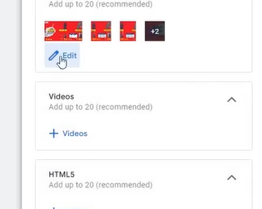
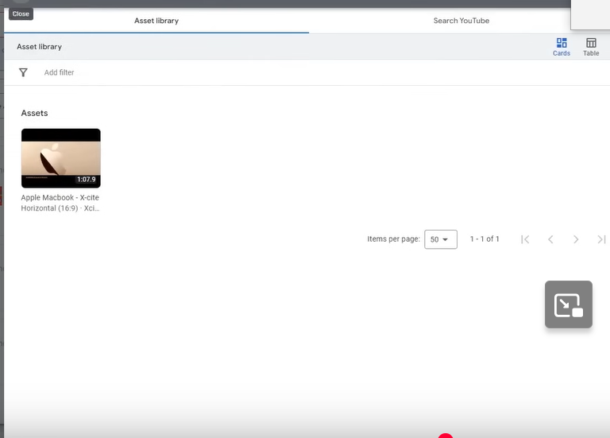
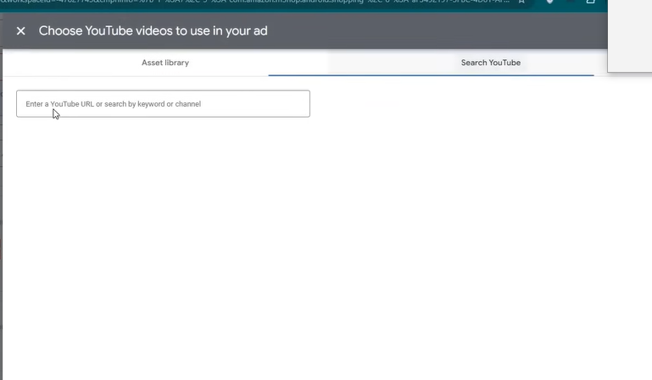
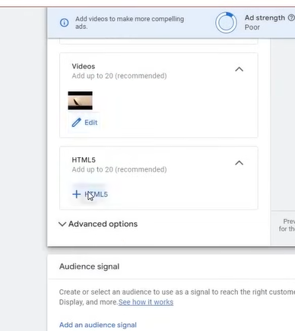
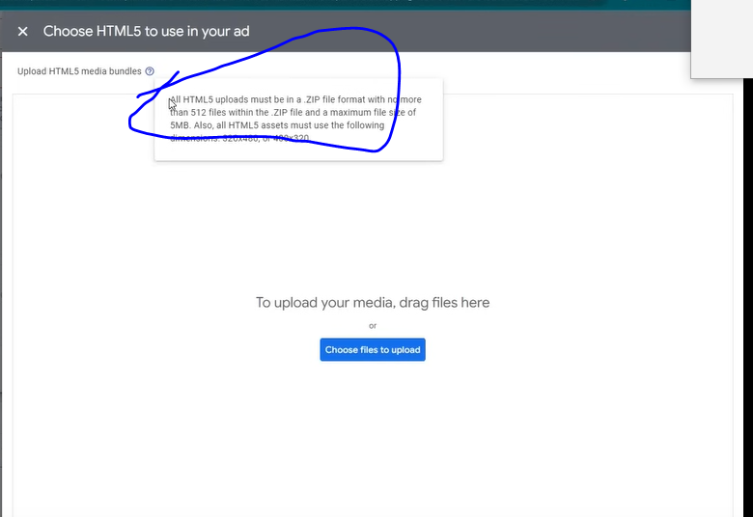
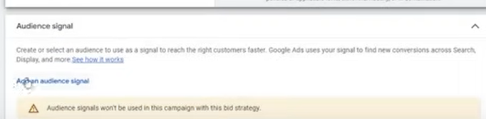
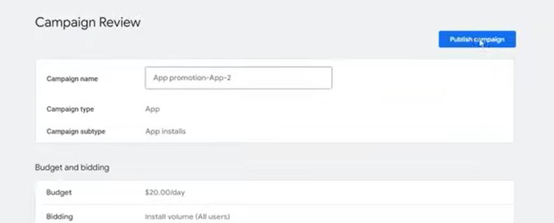
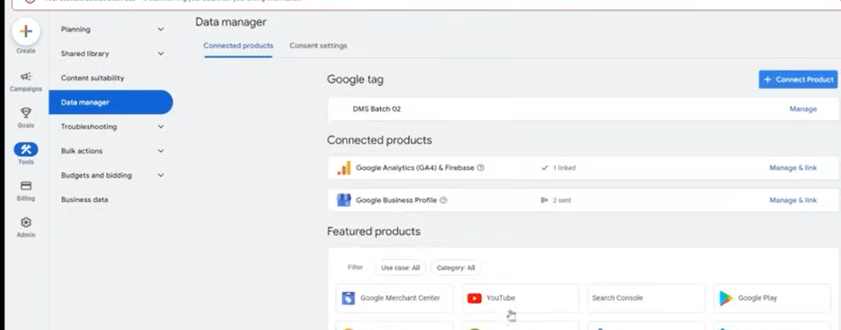
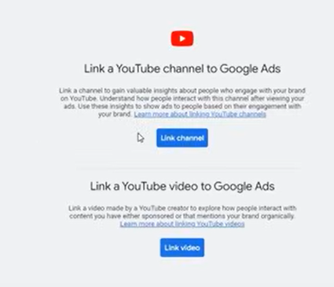
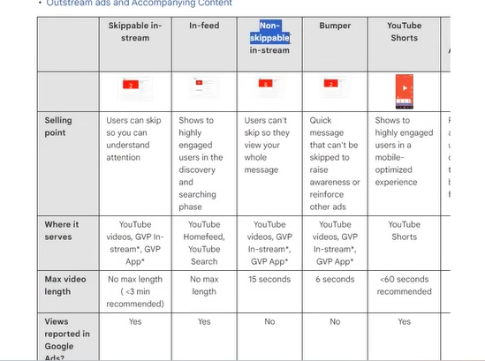
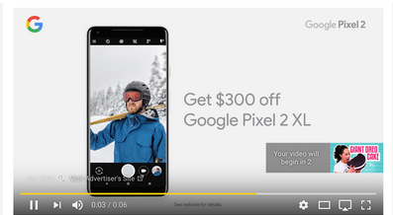
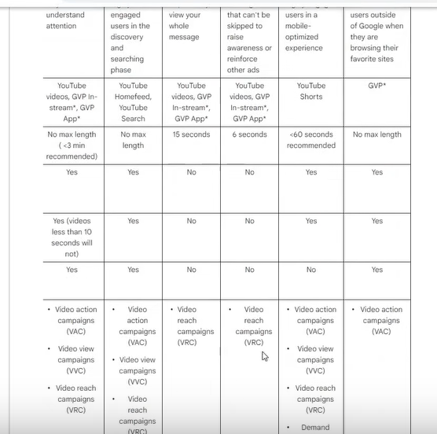
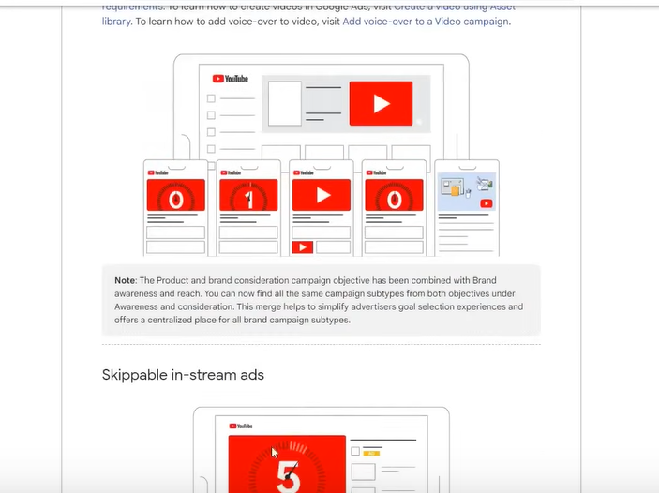
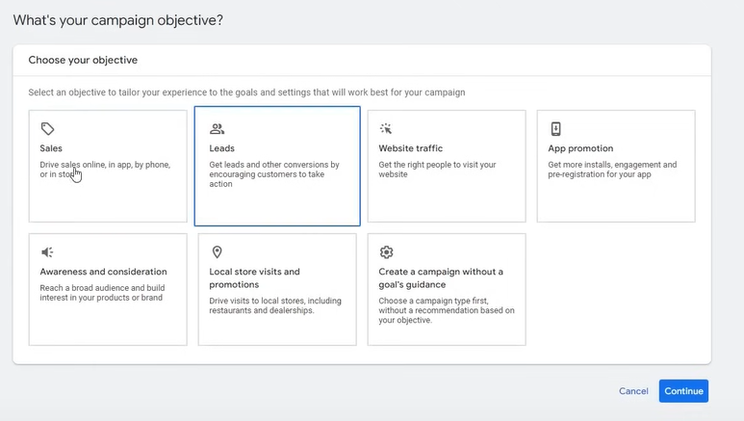
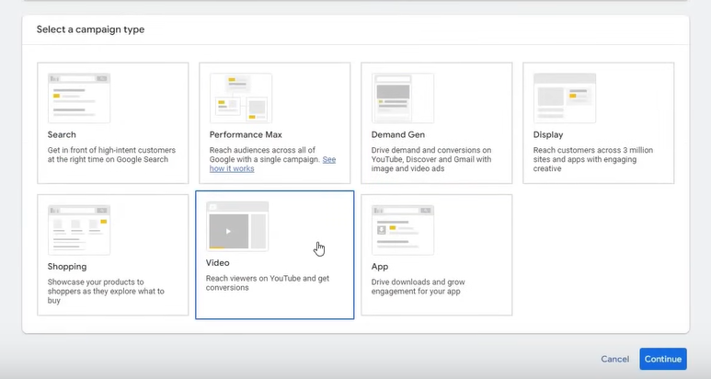
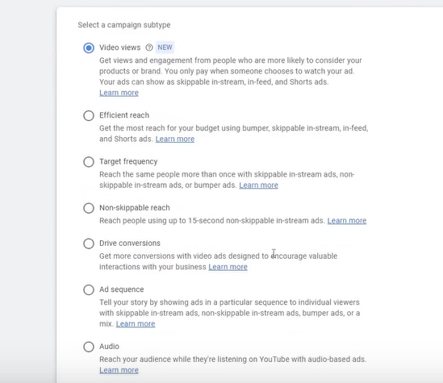
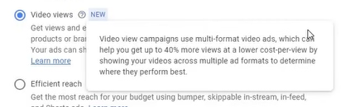
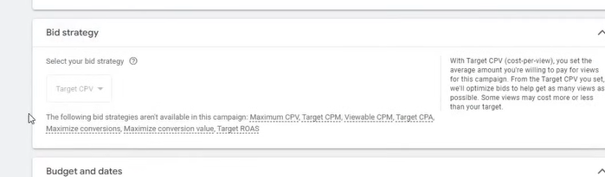
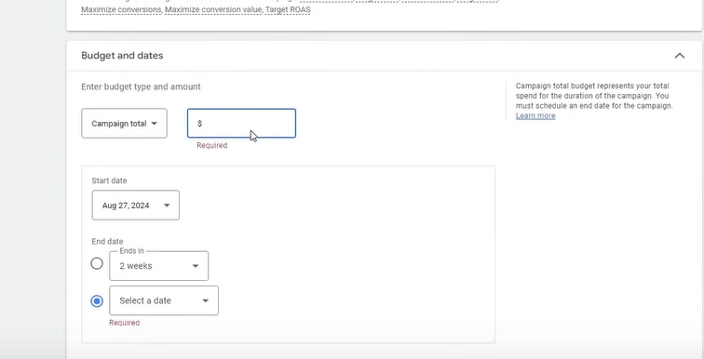
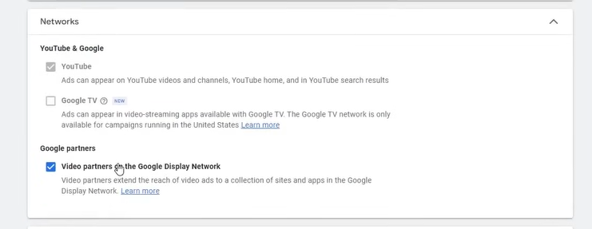
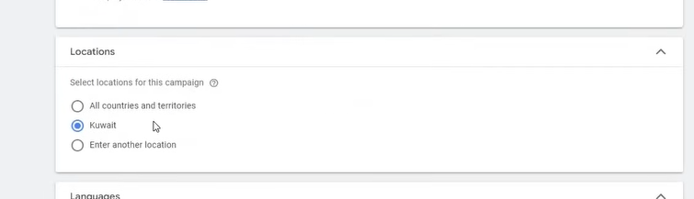
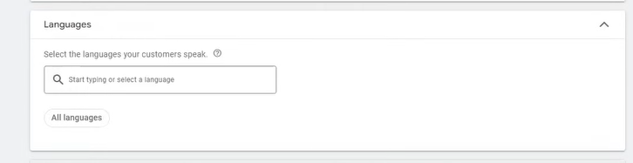
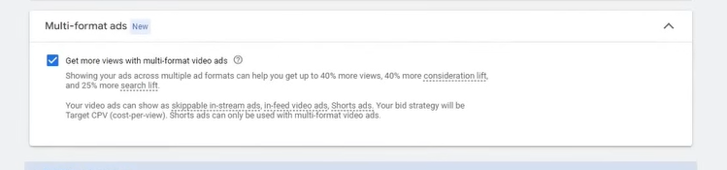
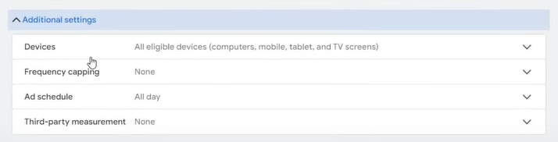
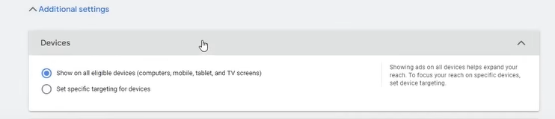
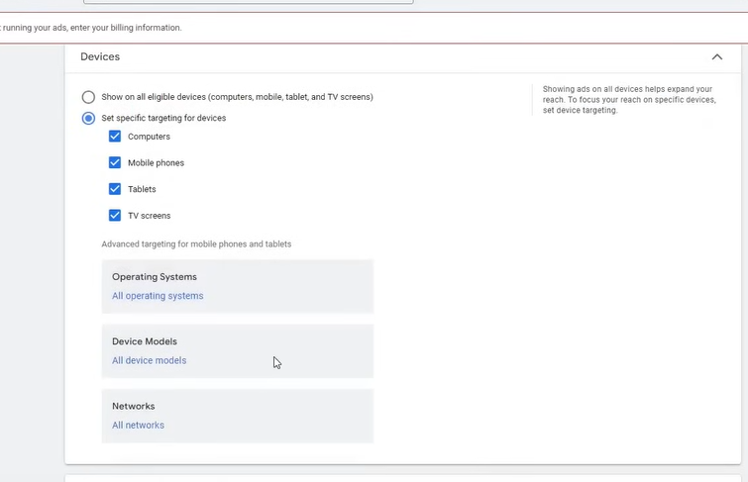
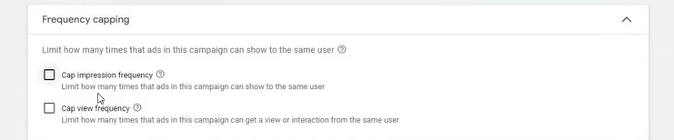
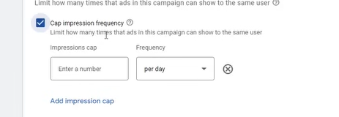
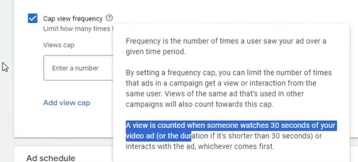
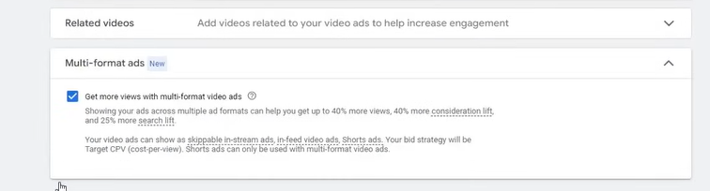
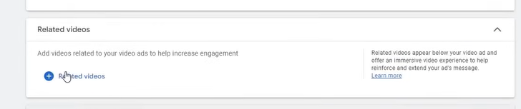
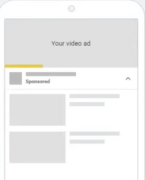
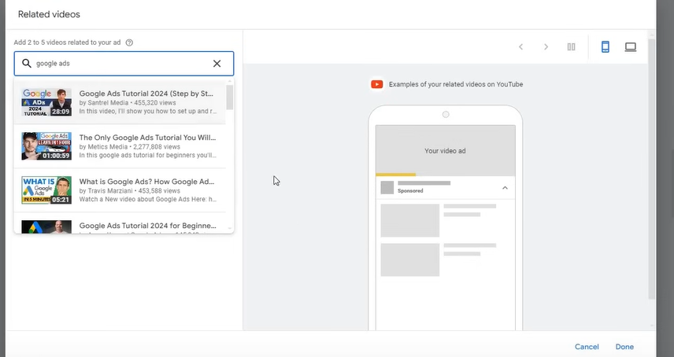
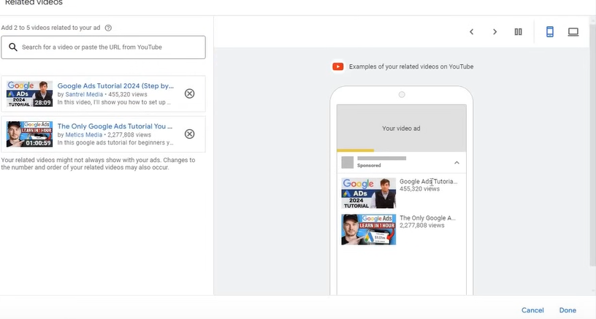
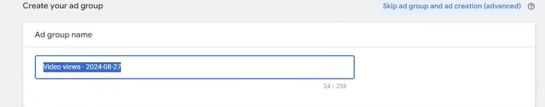
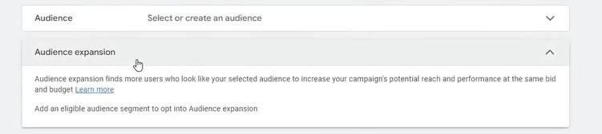
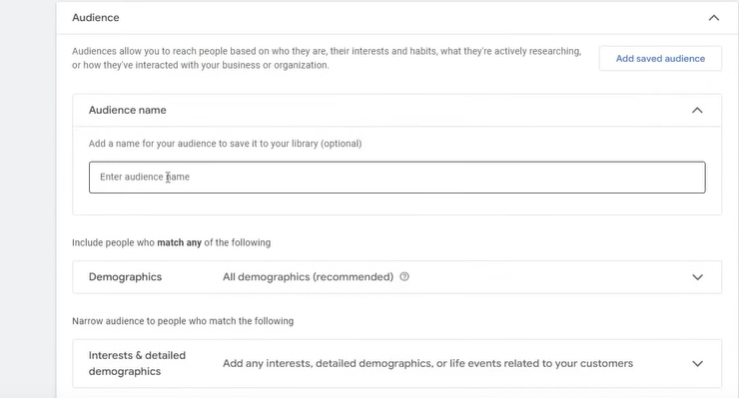
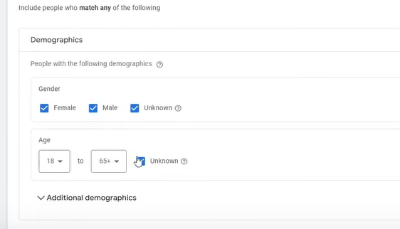
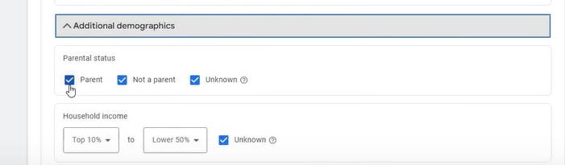
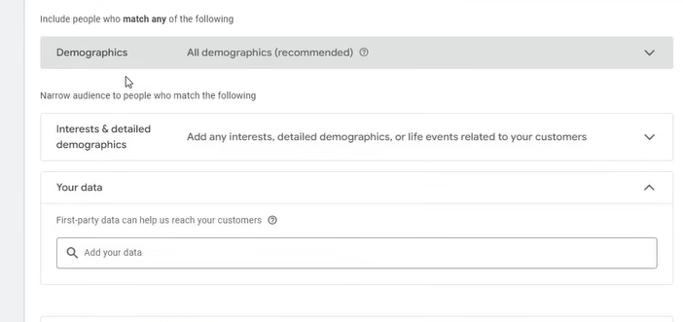
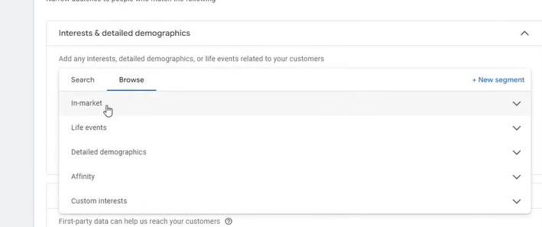
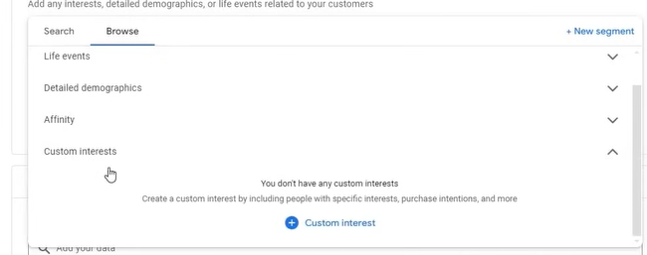
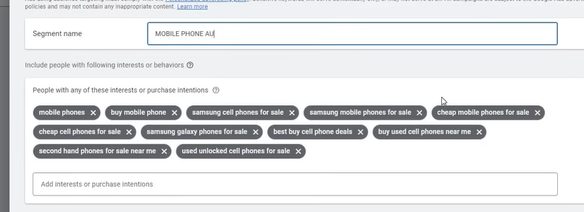
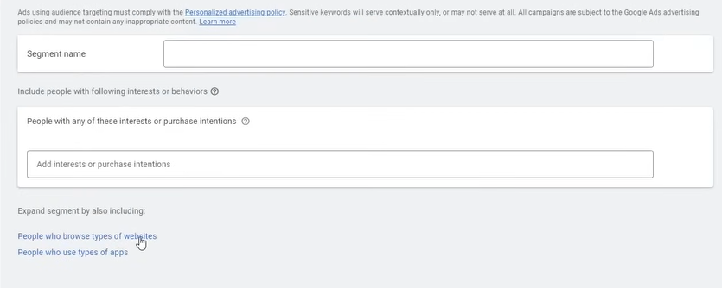
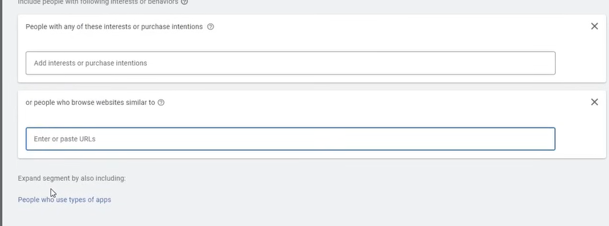
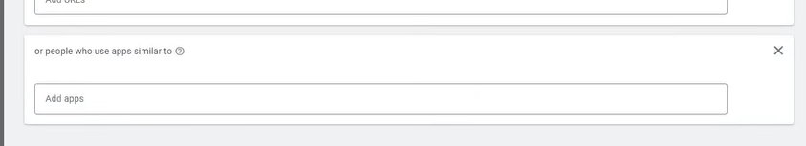
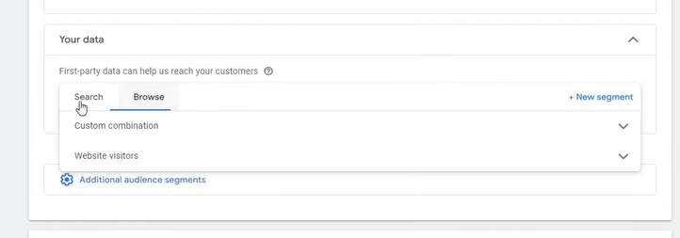
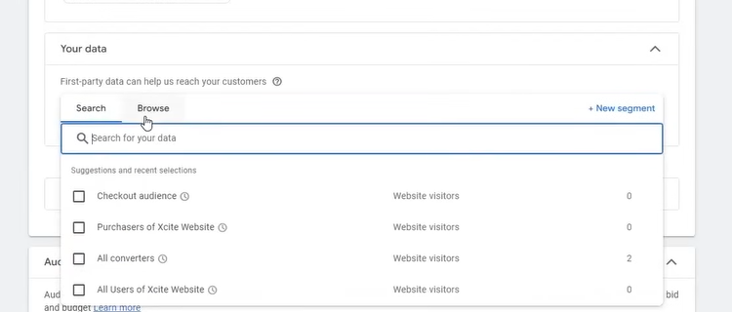
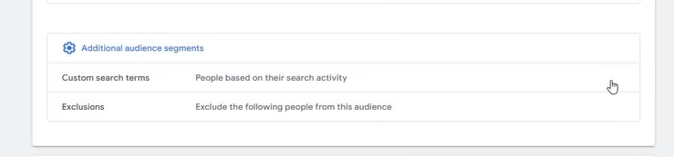
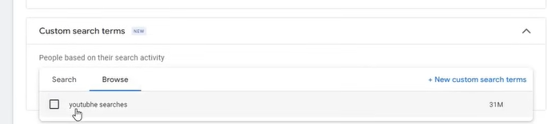
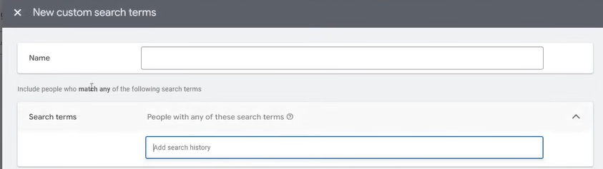
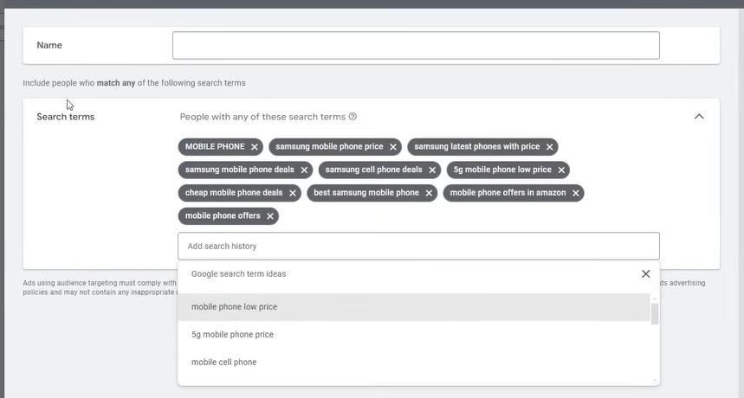
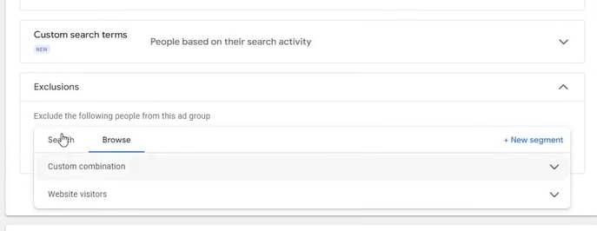
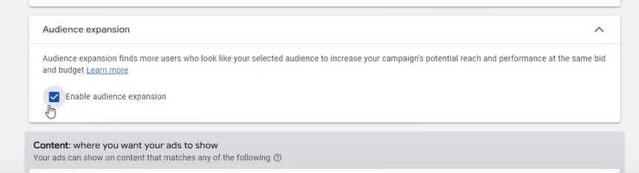
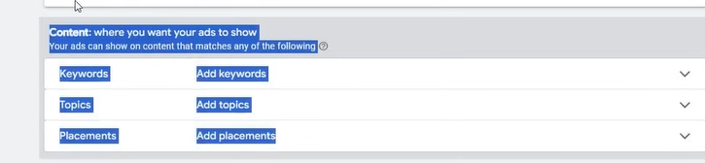
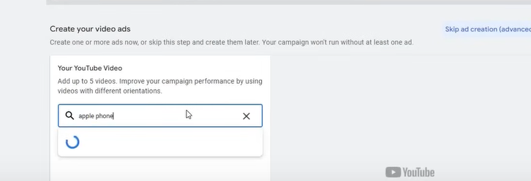
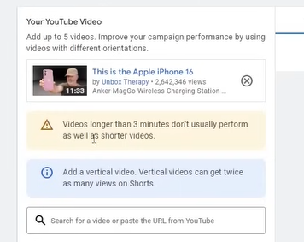
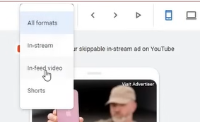
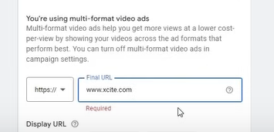
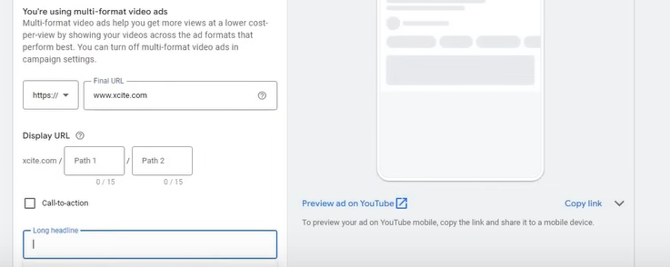
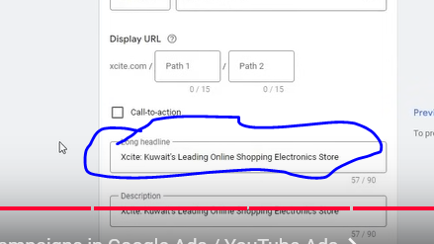
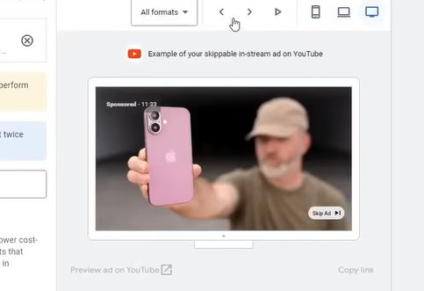
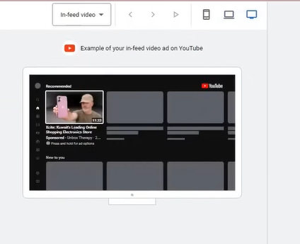
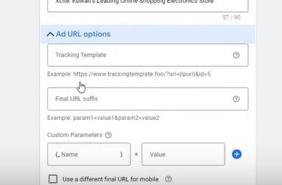
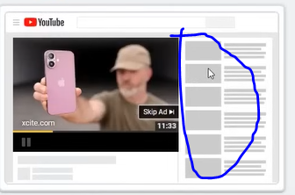
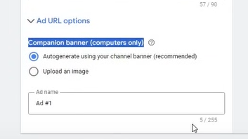
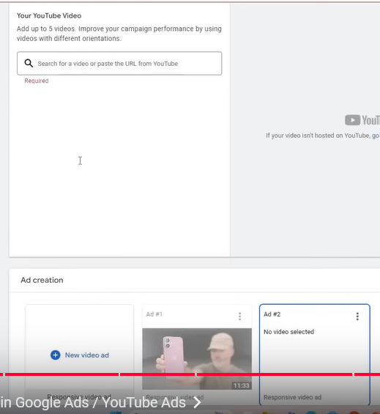
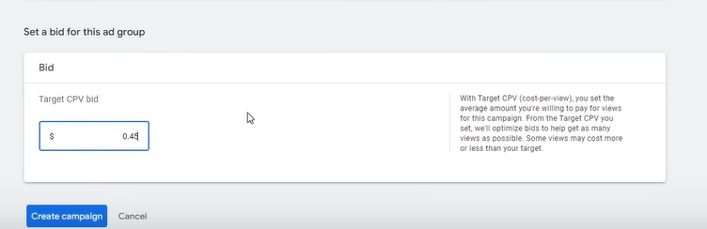
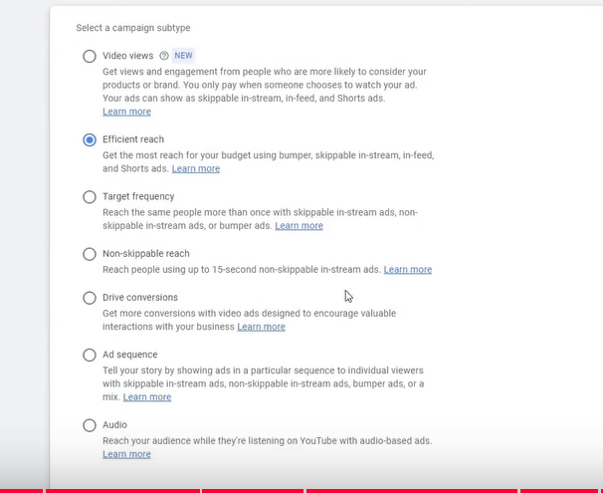
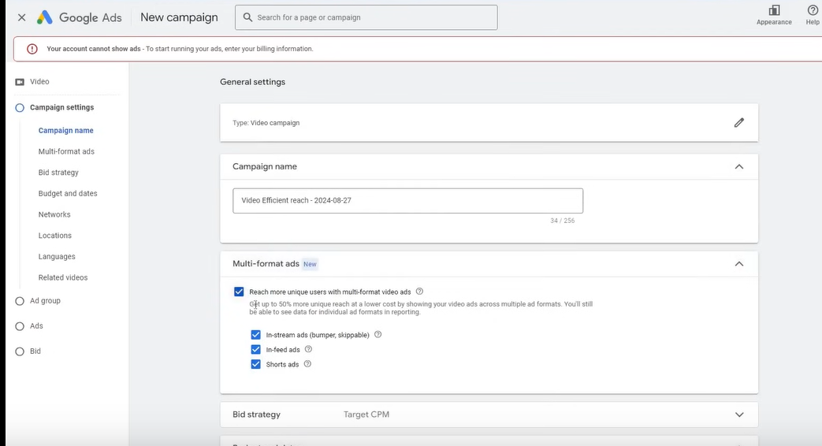
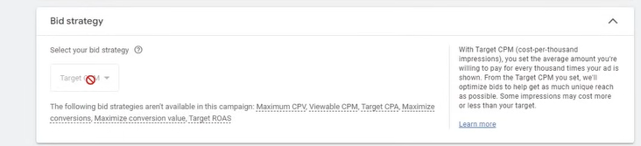
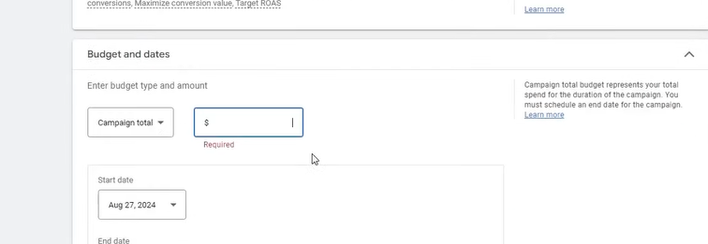
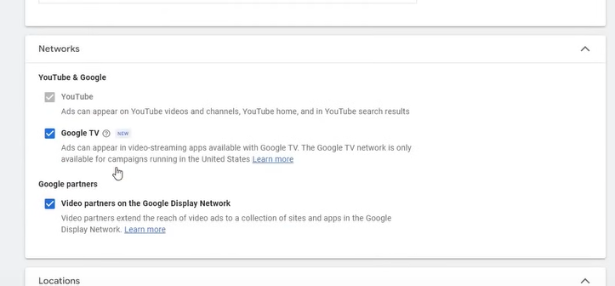
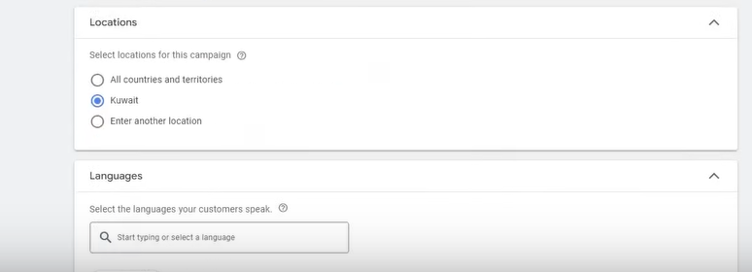
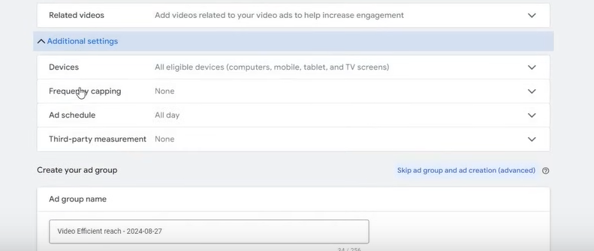
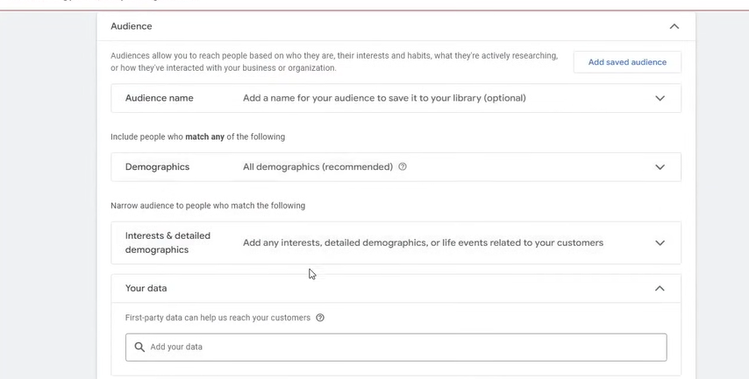
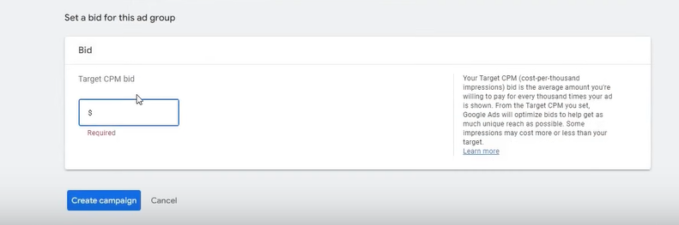
Phase 33
Click on video
Now you have to upload your video in youtube etc
And go to Search Youtube tab
Now paste the url of the video and then select it by checking it and then click on save button
You can click on HTML5 to make a banner designed by HTML
It is a slightly advanced technique
Only designer can help you making it
You have to give above marked information to them or these guidelines that we want that type of assets
5:40:30
Then he will made you this
We will conver this Audience signal later in performance section(who knows)
It will be applied now later it will be taught to us
Click on puiblish campaing to publish campaign
NOw our app promotion event is complerted
Teacher have added videos for the promotion of the app
Before assinf videos if you do this step then it will be better
Go to Tools and then to Data manager as shown above
You choose youtube in the featured products
Whateveer video you are addinf make it link with google ads the benefit of this is that you will have additional audience , how many subscriber ot views we have got on our video
How much percentage of videos people has watched and who has not matched with it so you get additional insights there So it is important for that
Again it is important for Video campaign
You have to link it one not again and again
Lesson 15:-
In this lesson we will learn about Video Campaigns
You can also call it youtube campaign because its mainly ad is shown I youtube only
First we need to understand the type of video campign and how they work
It will not happen that you make ad of a video and it works no
Its first type is
Skippable in-stream
It is the skippable ad that come in between of a video
It has no maximum length but the recommended one is three minutes
Next is infeed
Means inside youtube
I youtube when you scoll then you see ad or sponsored ads then it is called infeed ads it has noi maximum length
Now next is Non Skippable in-stream
Its maximum length is 15 seconds
These ads come in between the video and it is non skippable
Next is Bumber ad
Its length is 6 seconds
It is quick ad which you have often seen in it in TV commercial that there is a long format ad we make it a short term ads in between the video
IT can be termed as bumper ad but in youtube the bumper ad that has length of 6 second
In which you want to quieckly send your message to the people and increase awareness to the
People . Its example is below
Now comes youtube shorts
It has been a while when it was introduced
IN this when you see youtube shorts and then you see some sponsored ads in between shorts
Its maximum length is 60 seconds
Next is Outstream and accompanying content
It measn this ad is not visible in youtube
It measn that it is visibek outside yoututbe in different websites , indifferent apps
There you must have seen it in some websites nad there you can see some video ads then it is called outstream ads
If you have downloaded an app and ad is coming in it and video ads are coming in it then it is outstream ads
It also does not have any maximum length
Now the teacher has told us some basics
Now we creat some video ads
So create a new campaign
Normally you have to do it normally by the iobjective you have
If you have sales then choose sales and then cointinue and then choose video campaign
If you choose leads then the same process
By this way the best possible campaings options will be added
And you can make ad thro=orugh which you can get leads
Ad in case of sales some types of video will be added to increase sales
You can also do for Website traffic , App promotion, Awareness and Campaigns
If you make ads in a format in Awareness and campaigns then it should increase awareness
Since teacher want to explain all the format so he choosed Create a campaign without a goal’s guidance
So that we have all the format
IN campaign type we chose Video
Now you see above format
The video views is newly introduces format
What format it is made of it gives result also
If this is video view then it will give you video views
If it is efficient reach then it will give you more reach
Similarly if it is hten it will giv you more CL and lead
It is not like that you make coose video views and you are ising t for sale then it is not possible
We choose video views for now and click on continue
We does not see a bid strategy there that is target CPV
IT is locked and you don’t have to do anything special here
It will run by default
CPV means cost per view
It tells the charge thatshould cut on your view
You set campaign name
You tell the campaign total budget
You can tell the end date when it will be stopped
Here it will have networks
The google Partner s are those which we have talked in outstream
You can check it to run the video on other apps It is all upto yuou to check it
You now target a country
Then you choose languages
If you want more views then you need to check it
Now there are further options
IN display we tell that what devices are eligiv=ble to show these ads
You can check the first radio button to show ad on all eligible devices
Check the second radio button ro run ads on specific devices as shown above
You can even customize it according to operating system
Phase 34
You can also do for device modal
Now comes the frequency capping
It has two option that is
Cap impression frequency
Cap view frequency
In cap impression frequency you want to tell the ad should be shown to the persom how many times
You must have seen it normally that you are visiting a website and its ad are hown everywhere
You see an ad and you see it repeatedly why it is it happens because of frequency
It may be possible that they have set the frequect such that you see it repeatekdy
If they have not added any cap then it depends on Google How many times it shows to us
The ideal frequency ATT is 7 in frequency field you can set per day , per week, per month
Nor mallyh Teacher does not cap impression but views
Or even does not do it because google can handle it properly
Now comes Cap view frequency
If some oine view your ad for 30 seconds or for a particular duration (in general case)
If the person has viewed the ad for 30 seconds hten the ad will be shown to them otherwise will not show to them
On the other hand in impression even if the user just have scrolled the it will be counted as impression
You can set the frequency as 7 per weeks or 10 per weeks
Now comes the related videos
It means the video you will put beow the sponsors banner there will be videos related to it
Whatever related video you will ad will be shownb there
For example we search topic which our ad is based on
And then choose the video you want to come below your video ad
Now you can see above it will look like above
Ad group name should be proper
Now comes the audience
5:53:40
Here you select the audience that you want
First you give audience name
Now we tell the Demographics of the audience that we want to target
By unknown in gender we mean that the google don’t have any information about or they have not mentioned in their profile
NOw comes the parental status Do you have parents or not
You can do it according to the targeting you are selling
What type of people views you want in that case you can use
NOw comes the interest and details demographics
Here it gives different ways to target according to their interest
IN market are those audience which are ready to purchase and they are doing research to purchase
Affinity are those who have generatl interest in the product
IN detailed demographis it is advanced form of Demographics
IN life event syou can target according to the life events of a person
Choose according to your requirement
IN Browse tab they are grouped
Now comes the custom interest
You can create your own interest group click on it
And a side window opens up
IN segement name you name this group
You can expand your targeted audience by targeting url and target the people who are hitting this end point so click on People who browse types of website
You can expand the targeted audience by the app they use
Such type of is available for us
I think you can also include your own custom audience (or data of people)
like Checkout audience , all converters
Thhis data is collected by pixels maybe then google has a slight information that who are your customer that you want to target
Since it is a test account or demo website so it may face some errors
You can also add additional audience segment
Click on custom Search term edit button you will see when you hover over it
Maybe we are targeting according to the term searched
Click on new custom search term to make your own search term
So now the above custom search term is for youtube
If someone is searching and in there seach history there are terms which we are targeting or
These things are being searched tehn ad will be shoen to them
It is a new option
Now by exclusion we tell what type of audience we want to exclude form our targeting audience
It is not that necessary
If you check the Enable audience expansion
Then the google will go beyond that audience that you have targeted means it will find the similar audience that we have targeted
It is a good option that you want to test
We will learn it when we will run display campaign
We are skipping it for now but in Display campaign we will understand that
Now create your youtube ads by searching about the video and select it0020
Now after selecting a long vieo it is giving us warning that
Video is longet the 3 minutes nad short video should be chosen bfor better performance
Now we need ot see what type of format we can run on it
Lets see ehat type of format it si allowing us
It is a video views campaign so it is allowing us three format that is in-stream ,in-feed video
And Shorts
You can add multiple videos here
You can add upto 5 videos here
NOw when it will be clicked where to take us we have to give the url
We are giving it a url
Now if you click on Preview your ad on yoututbe then yout ad will be shown
Now in marked below you can add the headlines for your Ad
Phase 35
And then in below fierld you can add description x
IN your preview you can see it in different view
That is in TV, desktop, etc
You can see it in-feed video preview
Now we have add-url option as shown below
Skip it

You must have seen it while playing video in youtube then in side menu as marked above
There will be a banner will be shown then that is companion banner
It can be auto generated and can be uploaded manually by choosing the second radio button
If you keep it autogenerated then this will be enough
Better will be that there should be one video in each ad group
If you keep multiple videos then your headline will be very general(who knows) then they may not be matched with some videos then this will not be good and misleading then such thing should not happen
You can create video per ad
You can set target CPV (Cost per view ) (Maybe there is cost on impression in video ads)
Normally it is very cheap
Now we have understood this format now we will understand another format
We will see Efficient Reach as shown above
Now in campaign setting campaign name
WE set the campaign name and then what type of ad we want to run check that ad
By clickin on reach more unique users
You will use Multi-Format error
It is a new function that is a good thing because in video ads we don’t have optimization scope mainly automatic things run here and mostly thing good here
So we will test it then we will come to know that how much it is good
According to the teacher it should be tested

Now there is new bidding strategy that is Target CPM
CPM is the cost per 1000 impression
For every 1000 impression how much you want to pay is actually biding strategy
You can set Budget and dates for total campaign or other way
I think in network we tell what where ads will be shown whether in Google TV or other google partners
Then we have location or languages

We have studied Related videos previously
Now all other Additional setting we have already studied
And then audience will be shown
WE have already studied it
We have seen audience expansion
Now we wll find video like we did in video views campaign
You set bid by target cpm
You can keep it 2 or 3 dollar If it is not performing properly then gradually increase it
For example we have set our CPM to 3 dollars but no impression or click are coming in our videos so I will slowly lowly increase like 3.5,4 ,5 until impression or click start coming means until we have not reached the idol point
It is all about
There are only three format there that is
- In stream ads (bummer skippable)
- In-feed ads
- Shorts ads
you can use it for efficient reach
It is rarely used It can be used by companies who just want that people just see their ad and the purpose is not convergence they should just know about it convergence is not a good option
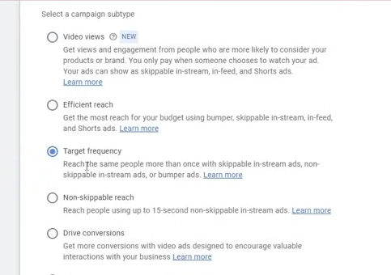
Now we see target frequency
It is a frequency based ads

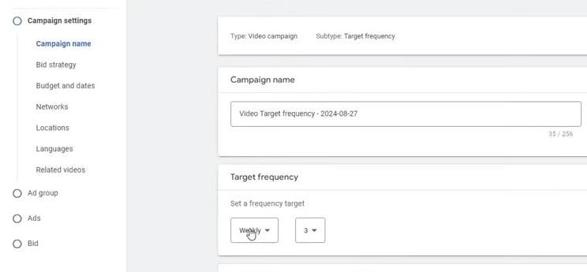
We can set the target frequency as Weekly or monthly
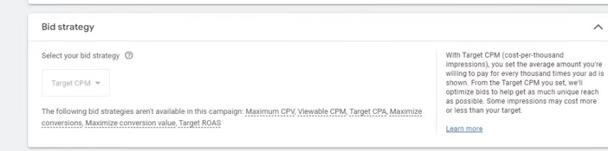
The bid strategy is usually target CPM and the other bid strategy cn be shown if they aer compatible oth the configuration we did
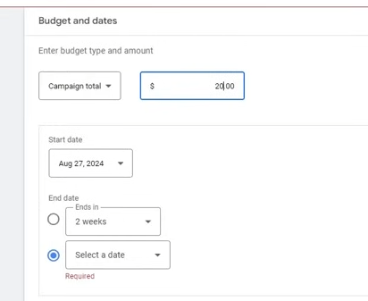
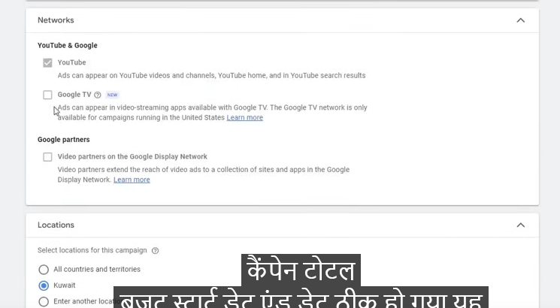
Now you can set language and related videos like we did previously
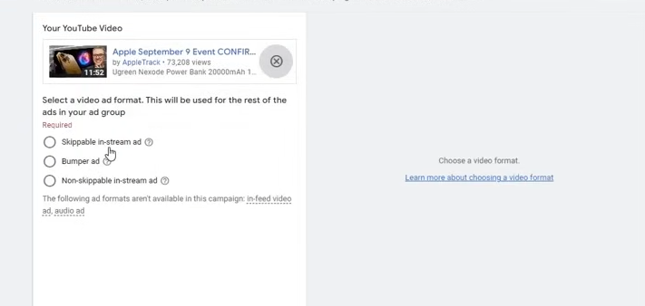
Like we did previously you can choose Skippable in-stream ad , Bumper ad, Non in stream Skippable ad
For a bumper ad you need a video of length less than 6 second
Now if you want ad in all the format
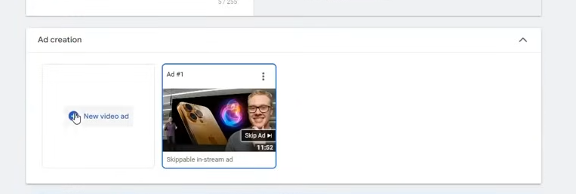
then after creating the ad click on new video ad
aand choose different format and follow the same target CPM like we told previously follow that way
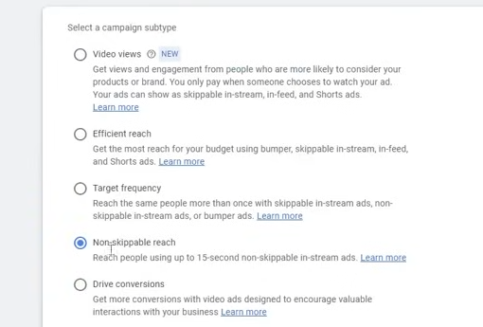
now comes the Non-Skippable reach
It is non skippable and its purpose is reach
If you wnant to reach then for that purpose you can increase it
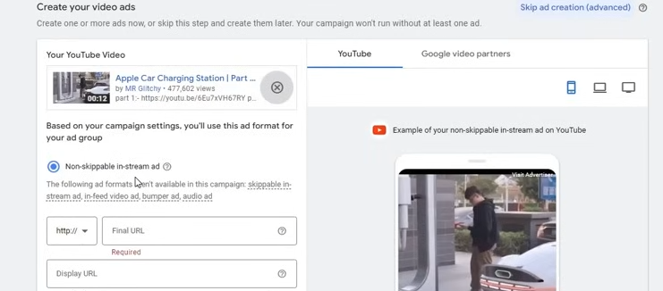
Now in create your video ads you have only Non-skippable in-stream format because it is compatible with this campaign subtype
It maximum length is 15 second
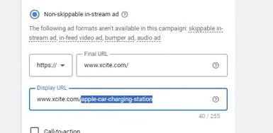
Now in Display url we place the url which we want to show to the user
It is not necessary that it exists
You can put your keyword there or service location (who knos)
You can see it in preview
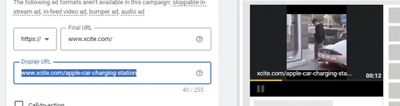
add call to action
All are same like previous
Phase 36
In this phase
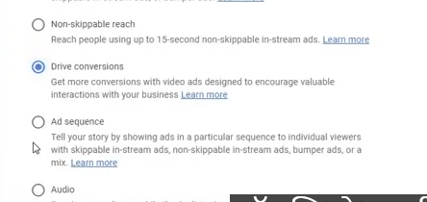
Now we do or Drive conversion
It is very important It is normally used for purchase and leads
So whenever we choose sales or leads then this option will be automatically given
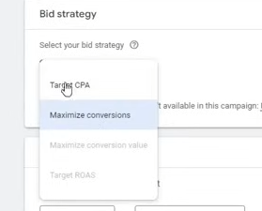
Now we have two bid strategy Maximum conversion and Target CPA
Teacher recommends for Maximize conversion because teacher has used it and we get good results here
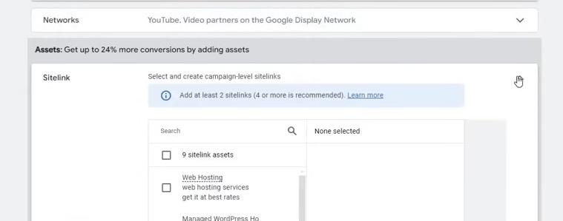
yo can later convert it into Target CPA but for starting maximize conversion is good because it will dp the bidding itself and you don't need to setup you just have to just make ads
You can add assets top this (I don't know) but according to teacher it is not needed
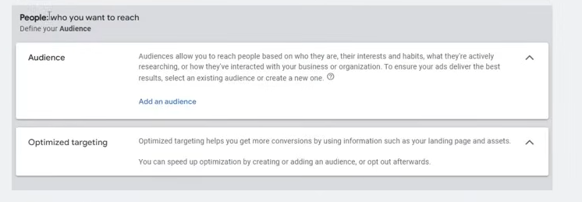
Define your audience
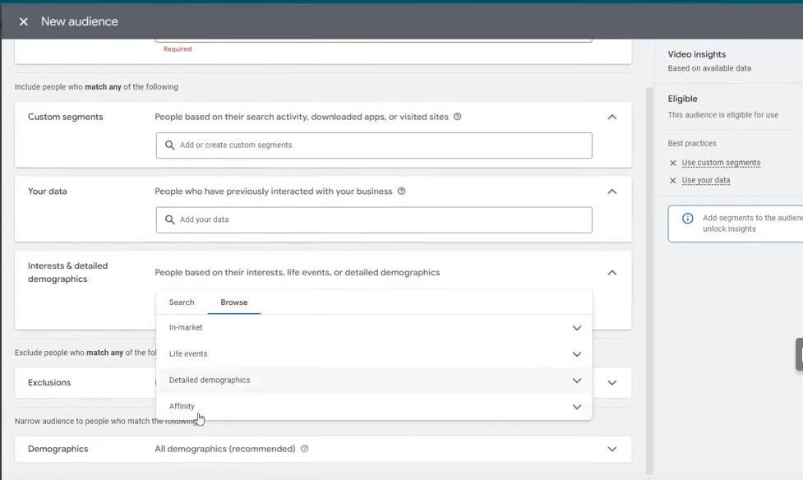
These are the same option you see in audience previously
We will later learn how to make audience
You can add at most 5 call to action
Normally 1 or 2 call to action is OK
You can add headline upto 5.
and you can also add at most 5 call to action and description
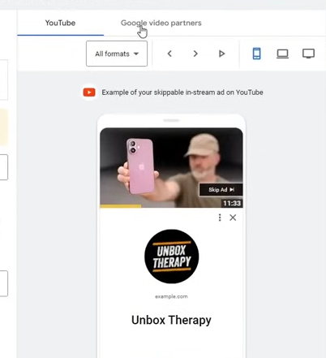
You can click on Google video partners to see how it will be visible in other website
Teacher recommends always make ad upto 3 ads
If you have only one then that's no problem but if you have more ads then you can make 3 ads
So it will be better option for you
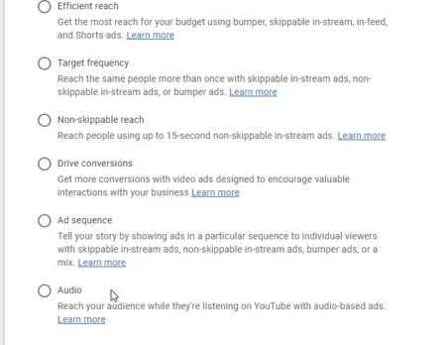
No comes the Ad sequence
you can skip the audio because it is not important
The thing that will be different here will be that will be sequence templates
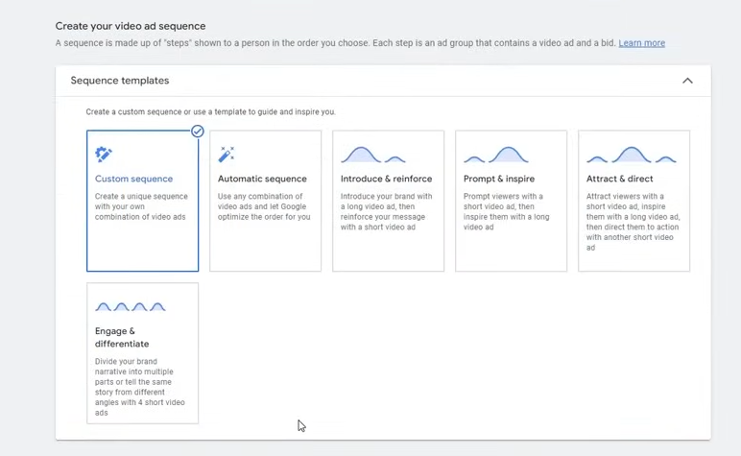

you can create sequence like showing one video and then moving to another video in a sequence
you can either use custom sequence or Automatic sequence and there are other templated They are given for different template they are suitable for different scenerios
One of the option is Engage and differentiate
in which you divide your baarand narrative into multiple parts or the same story from different angles with 4 short video ads
It is good if we wan to raise awareness about our product and we want that people should aware of it then you can utilise there
We choose automatic sequence
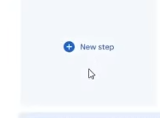
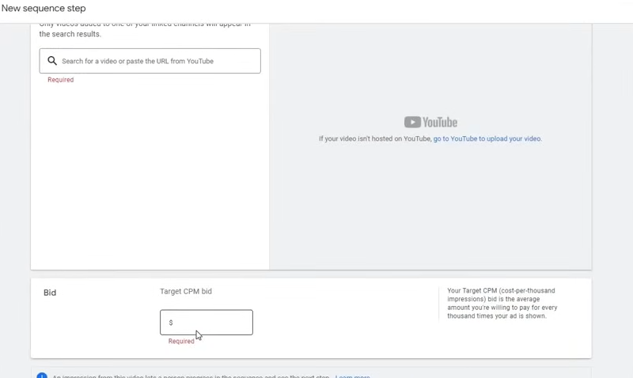
You need tp choose your videos
Choosing custom sequence will not be good because we already have some goo option of sequence
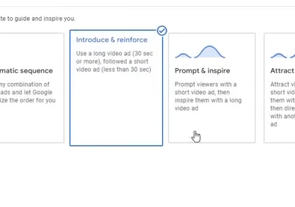
Now comes Introduction and reinforcement
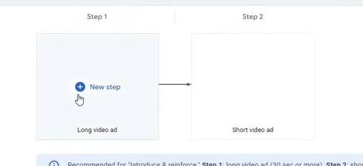
It has the above sequence
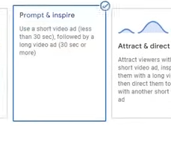
Now comes prompt and inspire
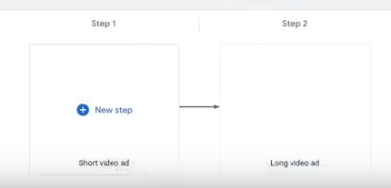
Where Short video ads come first and then longest video ads
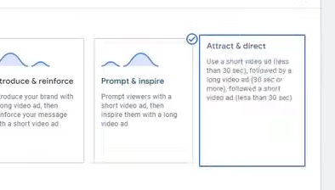
Now comes attract and direct
Its ad sequence is
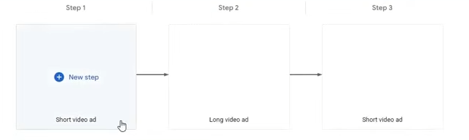
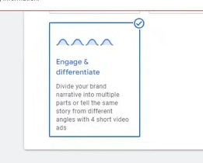
Now comes the Engage and differentiate
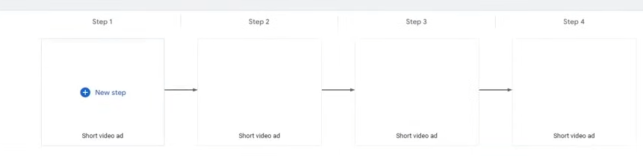
basically you are creating a set of combination that first video will be shownn then next video will be shown
Normally teacher does not use It
You cn use it in specific scenerio
It may happen that you maay need it in that scenerio
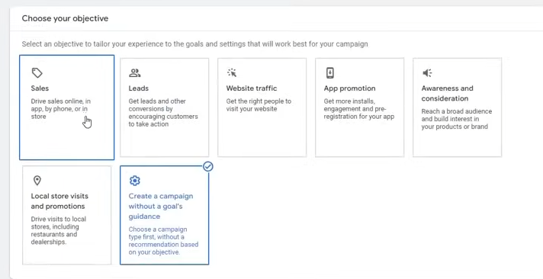
If you choose Sales in campaign objective
and in campaign type choose Video then
it will make automatically
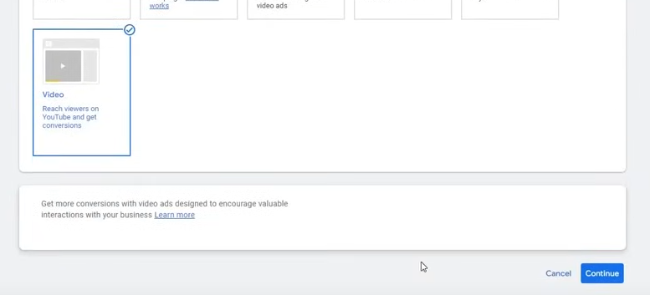
then it will make it automatically direct convergence
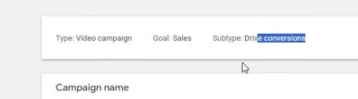
Now you can see tpe is video campaign but subtype is Drive conversion
Its means that this campaign type is best for bringing sales So it ill be ediotic if we go to other campaign type to bring sales so this option will be best
If we choose leads
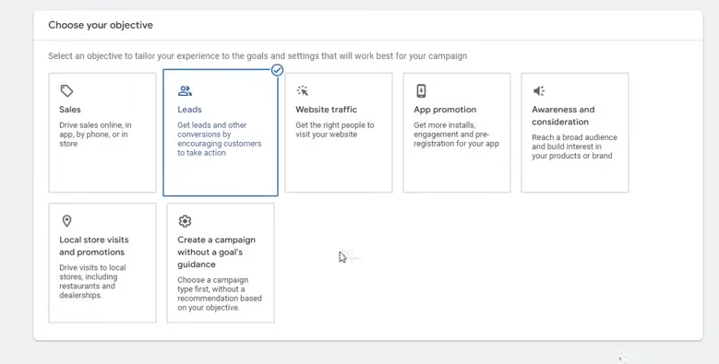
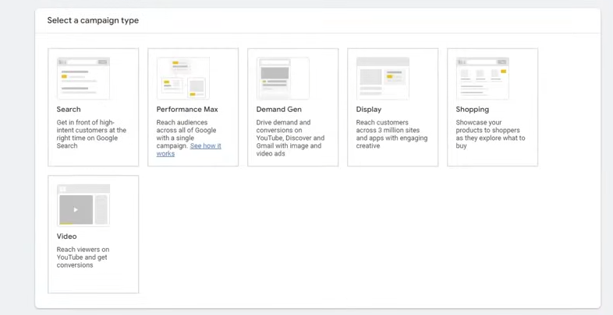
and then in campaign type choose Video
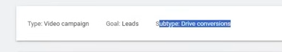
Now it is still a drive conversion
The teacher is saying that your audience should not be narrow
because if there are 1 billion people and you are targeting audience with 100 people then it will not give you any benefit
So make sure you restrict your tareting keep it open
It should be not like that it should be shown to exact person ou need ot be slightly broad
So that campaign can run on your audience
Now our Video campaign is completed.
Now we undersdtand Display campaign
Lesson 16:-
In this lesson we will learn about Display campaigns
Now again create a campaign
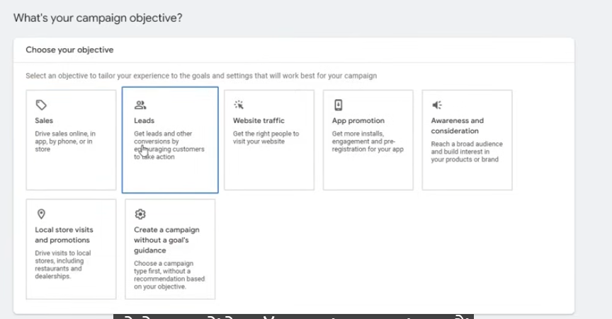
For ecommerce choose sales and lead choose leads in ecommerce objective
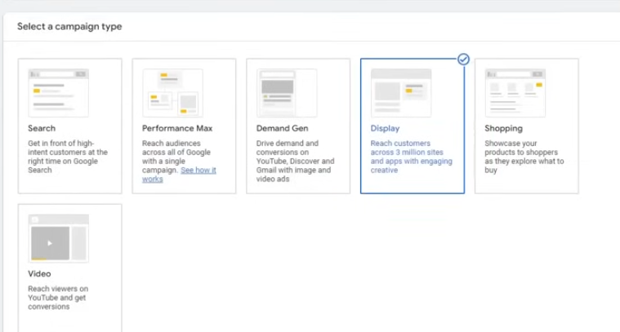
and no in campaign type choose Display
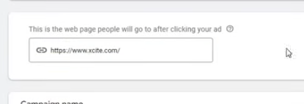
Tell the url
No tell the campaign name and then click on continue
Location language will be almost same
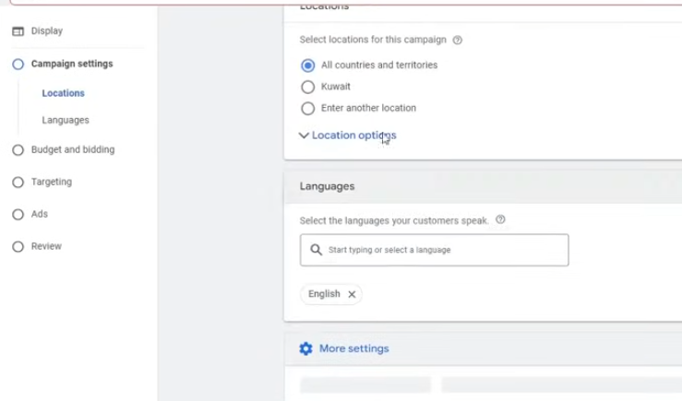
Now we come in budget and Bidding
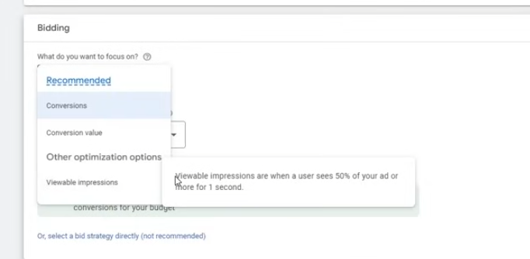
In bidding we have something new called Viewable Impression
It means If a user view your 50 percent ad for one second
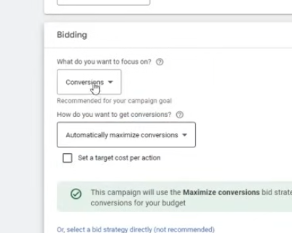
Normally choose Conversion and we set it to automatic as shown above
You can also do for Conversion values Both are good
Phase 37
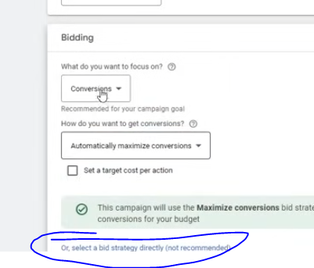

Select on the marked above to choose bid strategy directly
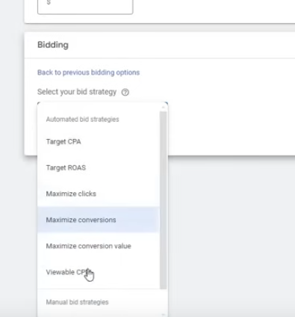
Click on next and then set the targeting
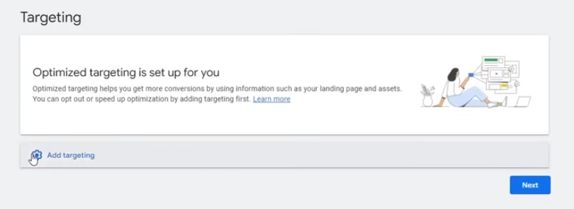
click on add targeting
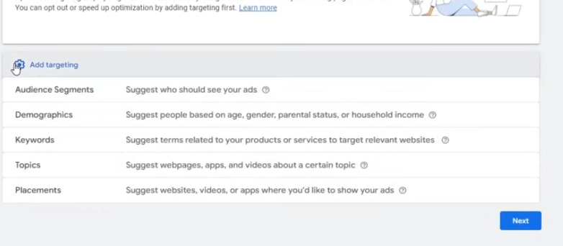
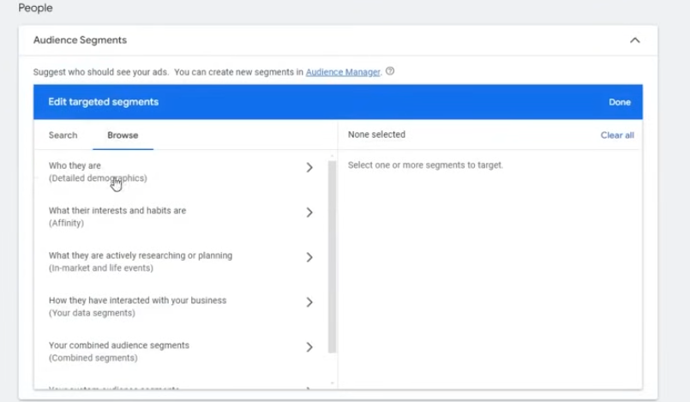
Click on Audience Segments

It is the same as we have studied previously

